2017
Annika k Bunkis
Algonquin College
10/17/2017
Rafting Expedition
Table of Contents
Part A: Journal 2
Day 1 2
Day 2 3
Day 3 5
Day 4 7
Day 5 8
Day 6 9
Part B: Trip Details 11
Menu 11
The Gatineau River 17
The Rouge River 18
The Jacques Cartier River 19
Companies Checklist 20
Conclusion 22
References 23

Part A: Journal

Day 1
The 2017 Outdoor Adventure program raft expedition began on the Gatineau River, specifically the route of Le Bonnet Rouge. I guided Crows and Log Drivers Dance. I guided the boat on Crows roughly five feet to the right of the first hump and eddied out to the right at the bottom. Our partner boat had gotten stuck as they had gone slightly too far left. Now if the students in the pinned boat were to go swimming down to their left, they would have been caught in a very sticky hydraulic. The boat was stuck firmly on the rock so that gave the instructors and the students time to look at the full picture. Sean got out of his kayak and made his way onto the rocks on river right to help give the students directions on what they should do to get the raft free. After a few moments of shifting their weight around in the boat, the raft got unstuck and they were off like a dirty old shirt.
Lessons learned from the first day of the expedition included learning that there are multiple ways to hit a rapid, and when in doubt hit it straight. If you’re going to mess up guiding, just make sure that you T-up your boat with the wave. Brit, our instructor, taught me how to pry from my hip to generate more power. She also gave the tip that when shouting commands to shout the side before the command, (for example: “RIGHT, BACK”,) as the crew will know first who you are talking to and will pay more attention to your commands. Another thing that was discussed is that a flat hand on top of the head is the signal for last boat.

Day 2
On day two of a river the guides would scout the rapid solo and the instructors would spend the day in their kayaks (or if you’re Alex Davey, in an inflatable banana boat looking dingy) rather than in the rafts with the students. I guided Cedar rapid. One thing that Brit noticed from my guiding is that I say things like “RIGHT HARD”. While this may work with other guides, Brit pointed out, that civilians will be confused. One can also get more out of their crew, by calling a back stroke on the opposite side rather than calling for hard paddling on one side.
One interesting thing that I noticed that when it came time to run Crows, was that the instructors formed a line with their kayaks in front of the rapid. By doing this, the instructors insured the rafts would not get stuck or go into the “no-go” zone on river left, avoiding a remake of yesterdays incident.
Lessons that were learned today were when one is TL make sure the ATL knows where to eddie out for safety, as well as a reminder to look for WORMS (Water, Obstacles, Route, Markers, Safety). Another thing we learned that day was that when your boat tombstones, the crew needs to get right back up after the hit to power through the rapid. We learned this as a fair amount carnage on Lucifers.
Adam lead a rope rescue lesson. He discussed one to one rope systems to free boats where you can clip or tie a rope to a strong part of the boat and pull on the rope from shore to rotate it in the current. By rotating the point in the current, the pinned raft should come free. Adam talked about three to one systems, also known as a Z drag which offers a crazy amount of force with little man power. To make a Z Drag tie the throw bag end of the rope to the stuck boat (attach this side just in case the part of the boat the rope attaches to breaks, the throw bag will slightly muffle the affects of the rope flying towards). Attach a sling to an solid anchor, then proceed to clip a carabiner and pulley to the sling (pulleys are important as they reduce friction). Attach the tail end of your rope to the pulley. Create a prussik loop going as far down the rope as possible towards the stuck boat and then clip a second carabiner and pulley to the prussik. By running your tail end of the rope through the pulley, one can then pull back on the rope thus creating a Z Drag.

Day 3
The third day of the expedition and the first day on the Rouge river. Throughout the trip, the instructors kept telling us to choose our own line and not simply follow the herd. So when it came to a little rock garden, that was what my boat decided to do and very soon our boat realized that we should have followed the herd in this situation. While everyone had gone river right, we thought we could see a path on river left. So as proceeded to forge our path we immediately realized our mistake as we spent what felt like forever getting stuck and unstuck, only to get stuck again. We got back on river right by having Nic (who started the rapid as the guide) hop out of the raft up stream and help push the raft as I hoped into the guiding position.
On this day, I guided the rapid called Washing Machine. My plan was to stay river right for the first feature in order to avoid the hole in river left then proceed to the second feature on the left with a right angle. It didn’t go completely as planned as in the middle, between the two features, I messed up my line, and got caught in an eddie. Now I used the eddie to move the raft back upstream and set up my line again for the second feature. This taught me to use my knowledge of hydrology on the go. Another lesson I learned from this rapid was that the right call isn’t always to get your crew to paddle hard but instead to use technique to get by. I learned this lesson because at the bottom my raft slammed into a rock because I called “PADDLE HARD” when I should have called a back ferry or simply let my crew. This is not the first time I’ve made the mistake of getting my crew to paddle through the rapid as I often made that mistake when it came to practicing surfing at Butterfly on the Ottawa.
Joel lead a lecture on Hydrology which included watching several videos of white water kayaking. Some topics that Joel discussed were the difference between a laminar flow (straight flow) and a helicoidal flow (water dealing with irregular objects causing a corkscrew-like flow), why waves form, and different types of waves (including standing waves, folding waves, breaking waves, and holes). Joel also talked about where the water flows the fastest in the current (a few inches below the surface), and boyle lines which is where the water divides between going downstream or back upstream into the hole.

Day 4
On the second day on the Rouge river, myself and five other guides got to the put in early with Seth and Joel, to blow up all the boats for the rest of the guides rather than everyone going to prep the rafts all together. We worked very fast as a team and it showed me what it would kind of be like prepping a day trip for a full group of people. It was a quick glimpse into what it is like to be a proper guide.
I guided the Rapid referred to as Mushroom. I called for a back ferry at the start to get our raft in the proper position for the line as we had shored up really close to the start of the rapid. The raft did get stuck on a rock at one point but that was almost guaranteed by the low water levels. I was able to get the raft unstuck by getting my crew to move their weight to the front of the boat and by having one of the crew assist me by being a front guide until we were fully off the rock.
We had a little extra time after running all the rapids to practice some rescues at the bottom of Washing Machine. We practiced tethered swims, throw bag rescues, and self-rescues. After preforming a few successful rescues via a throw bag and anchoring for a few rescuers, I got in line to do the rapid swim (even though the idea of swimming made me want to puke a little bit). Unfortunately (or luckily, depends on which way you look at it), Alex called an end to our rescue practice before it was my turn to swim. Even though I did not get a chance to swim, I was still proud of myself for lining up even though I was scared. With that rescue practice we learned how to give the proper amount of slack for a tethered rescue and how to self rescue safely. It was also good practice to help improve our overall skills with the throw bags.

Day 5
The first day on the Jacques Cartier river began with the Raft Olympics which consisted of who could create a Z-Drag the fastest, who can hit the target with throw bag, and who can blow up the raft the fastest. The most interesting task of the Raft Olympics, in my opinion, was the picnic table guiding race. The obstacle course involved one guide sitting in a raft while their crew was blind folded and had to carry the raft around picnic tables. Now if the guide gave the blind crew bad commands there was a high chance of the crew slamming their shins into the wooden picnic tables (which of course is not a very pleasant experience). Since I am small and have developed a good river voice over the course of the expedition, I was the guide. I found it difficult to stop laughing throughout the race which resulted in a few members of my crew hitting their legs against the picnic tables. This situation did teach me the importance of having simple commands and having a plan.
While attempting to surf in the hole at Bag of Knots, a raft got stuck in a side surf. Two members got dumped out of the raft, one member got stuck under the raft for a while before pushing off the raft, sending himself down under the recycling water and into the current underneath. He popped up downstream and swam into the eddie. The other member of the raft that went for a swim got stuck in the recycling water of the hole. Adam was able to pull the swimmer back into the raft. Adam got the crew to keep high siding to avoid flipping. The raft got out of the surf by being pulled out with a throw rope. After this raft was rescued, it was decided that the hole was far to sticky to keep attempting to surf. This situation did show me the importance of having other boats with you when you go on the river as it would have been a lot harder to get out of the hole had another person not been there to pull the raft out.
I learned today to always have your head on swivel when going through the rocks because once you get unpinned from one rock there is a high chance there is another rock near by waiting for you to get your boat pinned again. As well it is important to “make love to the rocks” or lean towards the rock when pinned to avoid dumping your crew out of your boat when pinned.

Day 6
On the final day of the expedition, I guided the Meat Grinder. To start the rapid the raft had to maneuver between a few rocks to get to the deep-water V so to do that I called one back stroke on the left to get use around the first rock followed quickly by one back stroke on the right to line use up for the deep water V. It was a pretty good line except the raft did get stuck closer to the bottom of the route causing the stern to go high up in the air making it difficult to guide as it seemed like my paddle was four feet out of the water even with me leaning over the side. To get out of this situation we played with our weight distribution and I got one of my crew to front guide to help turn the boat off the rock. Looking back on the line once we had safely made it to the bottom, it was pointed out to me that I should have called for a few draws from my crew on one side to avoid the rock where we pinned rather than relying on myself to angle the boat away. Before this situation I had only ever thought to call upon on crew for back or forward paddles.
The last rapid was Rock Garden, and it is exactly what it sounds like- a garden of rocks. It would take crews forever to get through the rapid as they would constantly have to figure out how to get unpinned. My boat decided to try something different going down this rapid. With the main guide sitting at the back of the boat, we had a secondary guide up at the bow. We went into this rapid in a super duck style and using this twin guide method, our boat ended up passing a lot of pinned rafts.

Part B: Trip Details

Menu
Sunday Sept 24th
Meal | What was programmed | What I personally had
Lunch | Packed own | - Cinnamon raison Bagel with Peanut butter and Nutella  - 1 energy bar
Dinner | - Noodles with ground Beef and spaghetti sauce  - 1 loaf of bread  - Caesar salad  - Squares for dessert  - Coffee, tea, hot chocolate | - Drank 2 nalgenes of water  - 2 pieces of bread  - 1 and ½ bowl of penne pasta with sauce and ground beef  - Caesar salad  - 1 rice square
Monday September 25th
Meal | What was programmed for group | What I personally had
Breakfast | - eggs  - english muffins  - Oatmeal  - Bacon  - oranges  - ½ box granola  - Skim milk | - 1 cup of coffee with almond milk  - 1 egg  - 1 english muffin  - 1 slice of cheese  - ½ orange  - Lots of bacon
Lunch | - Rye bread  - Apples  - 1 cucumber  - ½ iceberg lettuce  - Pastrami  - Trail mix  - Sliced cheese  - Mustard  - cookies | - 1 nalgene of water with a vitamin C package (brought from home)  - Rye bread  - Pastrami  - Iceberg lettuce  - Sliced cheese
Snack | - Chocolate bars | - 1 granola bar  - 1 Mcflurry
Dinner | - chicken breast  - rice  - celery  - carrots  - onion  - Asian 5-spice  - 9 rice krispie square  - Soya sauce | - 1 chicken breast  - 2 scoops of rice with chopped up celery and carrots  - 1 Rice Krispie square  - 1 Nalgene of water

Tuesday September 26th
Meal | What was programmed | What I personally had
Breakfast | - Bagels with Cream cheese  - oranges  - Oatmeal  - ½ box granola  - Milk | - 1 bagel  - Cream cheese  - 1 cup of black coffee
Lunch | - Wraps with hard boiled eggs, Celery, cucumber, cheese  - 1 bag mini carrots  - 1 bag of cookies | - 2 Nalgenes of Water  - 1 wrap  - Meat  - Sliced cheese  - 1 cookie
Snack | - 9 granola bars  - Dried fruits | - 1 granola bar  - 1 apple juice box
Dinner | - Beef strips and rice  - Teriyaki sauce  - Onion, carrots, celery  - Pudding cups | - Chocolate pudding cup  - beef and rice  - 2 p cookies  - 1 Nalgene of water  - 2 cups of tea

Wednesday September 27th
Meal | What was programmed | What I personally had
Breakfast | - Oatmeal with raisins  - Skim milk powder  - Bagels with Cream cheese | - 2 bags of oatmeal  - Raisons  - Brown sugar
Lunch | - Wraps with, Sliced ham, tomato, iceberg lettuce  - Apples  - Cookies | - 1 Medium Ice cap  - Steak and cheese panini
Snack | - Pre-mixed dried fruit and nuts | - 1 breakfast bar  - Carrot cake muffin
Dinner | - Chicken strips with quinoa, carrots, Sweet and sour sauce, Onion, Celery  - Rice krispie squares | - 1 ½ Nalgene of water  - 2 cups of tea  - Quinoa, Chicken, Tomatoes  - Dried fruit
Thursday September 28th
Meal | What was programmed | What I actually ate
Breakfast | - Instant oatmeal  - english muffins with Crean cheese  - Granola  - Milk | - 2 bags of instant oats  - Brown sugar  - Raisons  - Chocolate chips
Lunch | - wraps with tuna, alfalfa sprouts, tomato, cucumber, lettuce, hummus  - Cookies  - Dried fruit | - 1 wrap  - Hummus  - Tuna  - Alfalfa sprouts  - Lettuce  - 1 nalgene of water
Snack | - 8 granola bars  - 8 apples | - 1 granola bar
dinner | - penne pasta with Alfredo sauce, Canned tomatos, Italian sausage  - 1 French loaf  - Pudding cups  - Coffee, tea, hot chocolate | - garlic bread  - Penne pasta with Tomato sauce, Italian sausage  - Dried pineapples  - 1 nalgene of water
Friday September 29th
Meal | What was programmed | What I actually had
Breakfast | - Oatmeal  - Left over bagels etc.  - Coffee, tea, hot chocolate | - 2 bowls of oatmeal with Chocolate chips, Brown sugar  - 1 rice krispie  - Dried pineapples
Lunch | - Wraps with ham, turkey, or chix, lettuce  - Oranges  - Cookies  - Juice  - Coffee, tea, hot chocolate | - Rye bread  - Tuna  - Mayonnaise  - 1 nalgene of water
To ensure proper hygiene, our group used hand sanitizer before preparing the food to help stop the spread of germs. As well if one of team members was feeling under the weather we did not have that member help when it came to preparing the food to avoid getting the rest of the group sick. We created a grey water pit at every location so the used water could be properly disposed of and made sure to clean up all our garbage after we were done

The Gatineau River
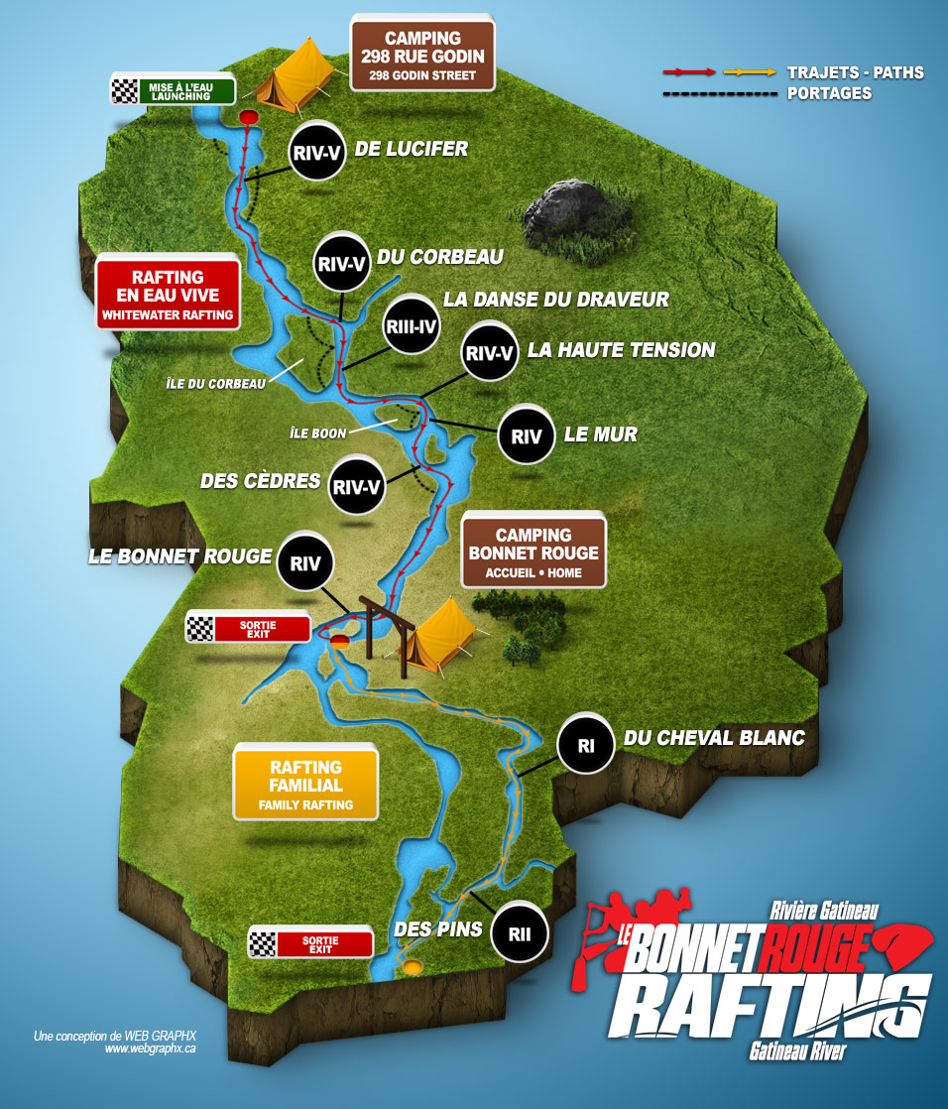
(River The sections)
The Rouge River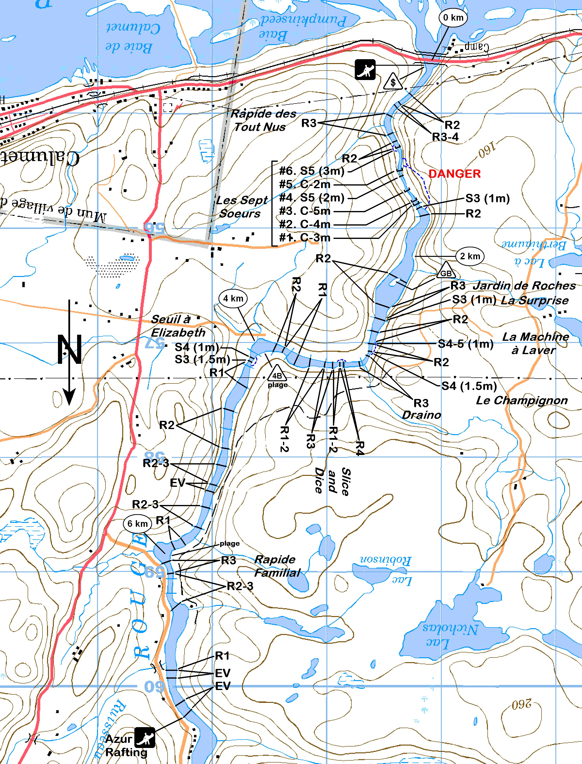

Rivière Rouge
Les Sept Soeurs

Por
t

s
:
•

•

•

R2: rouleau-école à droite
vers la moitié du rapide.
Slice and Dice
R4. Reconnaissance par la
:
rive gauche. Assurer une bonne sécurité car
les rapides en aval sont difficiles et continus.
Draino
: dans le virage, avec quelques
rouleaux. Il est préférable de s’arrêter à
droite en aval, pour aller reconnaître les deux
rapides suivants.

Le Champignon
le seuil impressionnant en
:
forme d’éventail est précédé de deux
rouleaux :
le
rouleau des Machos
, suivi du
rouleau des Nonos
(
celui-ci peut être
dangereux).
La Machine à Laver
est un seuil dont le
goulet principal est à droite de la rivière
barre le coté droit de la rivière. À eau basse,
c’est le « playspot » par excellence. À eau
haute, il se forme un
rappel dangereux
à
droite, et il y a au centre-gauche (ou à gauche
selon le niveau) un passage à l’économie (S3)
appelé
La Sécheuse
.
R2-3: rouleau à surfer au
début du rapide centre-droite.

Le stationnement est interdit en bordure du chemin de la rivière
Rouge, sur toute sa longueur. Moyennant quelques dollars, on
peut stationner chez Azur Rafting, puis portager environ 100m
pour atteindre le point de mise à l’eau sur une petite plage.
(Riviere Rouge Les sept soeurs)

The Jacques Cartier River
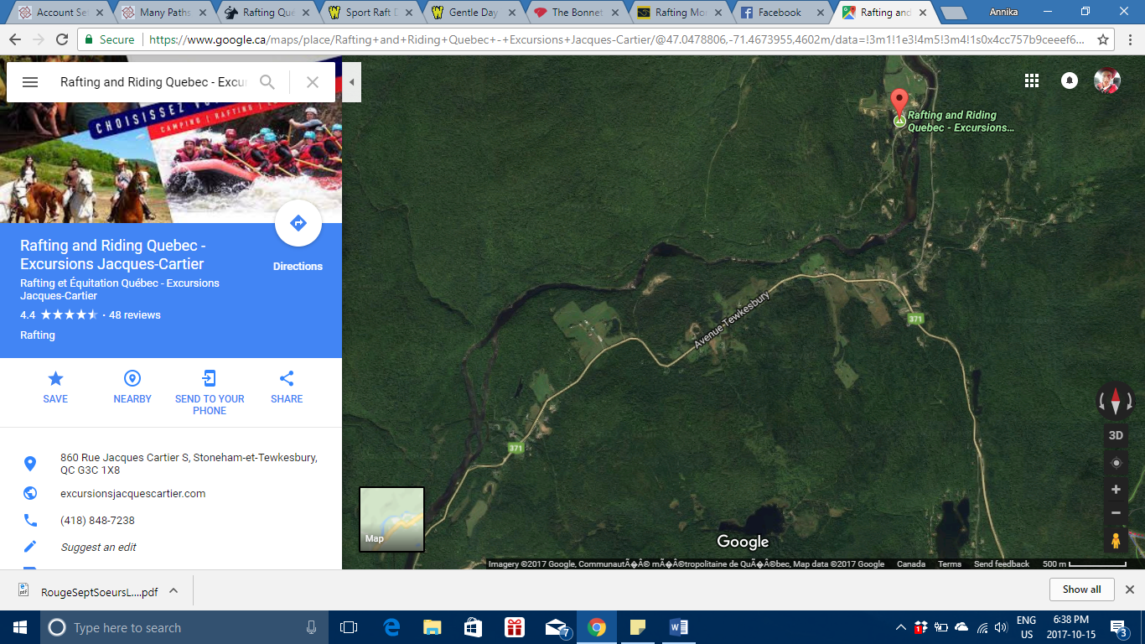
(Excursions Jacques Cartier, n.d.)
Shape on map | location
Red pin | Put in
Lightening bolt | Appetizer
Triangle | Fragens
Diamond | Meat grinder
Sun | Top hat
square | Wallet
moon | Meat grinder
heart | Bag of knots
Star | Rock garden
arrow | Take out

Companies Checklist
Facility | Wilderness Tours | Bonnet Rouge | Nouveau Monde | Excursions Jacques Cartier
Location (address, nearest town) | 503 Rafting RD, Foresters Falls, ON K0J 1V0  Nearby Pembroke and Arnprior | 211 Rivière Gatineau road South,  Ste-Thérèse-de-la-Gatineau, | 25 Chemin Des Sept Chutes, Grenville-sur-la-Rouge, QC J0V 1B0 | 860 Rue Jacques Cartier S, Stoneham-et-Tewkesbury, QC G3C 1X8
Contact info | 1.888.723.8669 raft@wildernesstours.com | 819-449-3360  Toll Free: 1-855-449-3360 | 1 800 361 5033  info@newworld.ca | info@excursionsjacquescartier.com  (418) 848-RAFT (7238)
Welcome sign | Yes | No | Yes | yes
Main Building | Yes | No | Yes | Yes
Restaurant | Yes | No | Yes | No
Spa | No | No | Yes | No
4 season operation | No | No | No | Yes
Retail section | Yes | No | Yes | No
Waiver | Yes | No | Yes | Yes
Trip video purchase | Yes | No | Yes | Yes
Pool | Yes | No | Yes | No
Sports court | Yes | No | Yes | Yes
Tent camping | Yes | Yes | Yes | Yes
Rv parking | Yes | Yes | No | Yes
Rustic cabins | Yes | No | No | No
High end lodging | Yes | No | No | No
Trails on site | Yes | Yes | Yes | No
Outhouses | Yes | Yes | Yes | yes
Take out on site | No | yes | no | no
Put in on site | No | no | no | yes
Raft storage on site | No | No | Yes | Yes
Wet suit rentals | Yes | Yes | Yes | yes
Bike rentals | Yes | No | No | no
Bungee or ropes course | Yes | No | No | No
Kids programming | Yes | no | yes | Yes
Multi-day trips | No | No | Yes | no
Kayak school | Yes | NO | No | No
Environmental awareness | Yes | no | yes | yes
Staff housing | Yes | no
Other (describe) | offers a sport raft rafting trip in 6 person boats which is considered adventurous while on the opposite side of things they also offer a family gentle raft trip on the middle channel. | offers a package with a 3 hour raft trip, and a meal at the end. Also have a weekend package which includes two rafting descents. | offers a variety of packages including a family raft trip and a rafting express which is a quick 2-3hr long raft descent. | Excursions Jacques Carter offers sport rafting packages as well as youth oriented rafting packages

Conclusion
In conclusion, my biggest personal learning experience began before the first rapid. I still have a healthy fear of white water and therefore was quite nervous about going down the first rapid, Lucifer’s Anus. I asked our Pod Instructor, Brit, if she had any advice. “If something scares you, then you should always do it,” was her response. I kept that advice in the back of my mind throughout the entire trip from getting on the water every morning, to lining up to swim a rapid.
We were very lucky throughout the week as the weather was irregularly hot and sunny for this time of year, which offered the participants the chance to go “skin to the wind” as Alex Davey would say.
The first two days spend travelling the 7.5-kilometer route of the Gatineau was full of big hits while the 8 kilometers of the route we took on the Rouge River was full of pinned rafts. The first four days of our trip prepared us for 9.6 kilometers on the Jacques Cartier that offered us a place to really test our skills.
While each river posed different challenges, be that by type of rapid or amount of rocks exposed due to water levels, I cannot choose one that I enjoyed more than the other. I learned a lot during this trip as it simulated what it is like to be a true white water guide. And while white water still slightly terrifies me, I enjoyed the whole rafting experience way more than I thought I would (and I already knew beforehand that I was going to like it). I still have a lot to learn as a raft guide but this was an amazing first step and allowed to me find my river voice. This truly was an amazing experience and I am grateful to have the opportunity to be apart of it.

References/
(n.d.). Retrieved from https://excursionsjacquescartier.com/rafting-jeunesses.html
(n.d.). Retrieved from https://www.google.ca/maps/place/Rafting+and+Riding+Quebec+-+Excursions+Jacques-Cartier/@47.0478806,-71.4673955,4602m/data=!3m1!1e3!4m5!3m4!1s0x4cc757b9ceeef647:0xd0410f72fc12b837!8m2!3d47.0632879!4d-71.4286941
Excursions Jacques Cartier. (n.d.). Retrieved from Google maps: https://www.google.ca/maps/place/Rafting+and+Riding+Quebec+-+Excursions+Jacques-Cartier/@47.0478806,-71.4673955,4602m/data=!3m1!1e3!4m5!3m4!1s0x4cc757b9ceeef647:0xd0410f72fc12b837!8m2!3d47.0632879!4d-71.4286941
Rafting Express. (n.d.). Retrieved from New World Rafting: https://www.newworld.ca/forfaits/rafting-express/
Rafting Jeunesses. (n.d.). Retrieved from https://excursionsjacquescartier.com/rafting-jeunesses.html
River The sections. (n.d.). Retrieved from Le Bonnetrouge Rafting: http://www.bonnetrougerafting.com/en/river/the-sections
Riviere Rouge Les sept soeurs. (n.d.). Retrieved from cartes pleinar: http://www.cartespleinair.org/Canot/04/RougeSeptSoeursLeduc.pdf
Whitewater Rafting. (n.d.). Retrieved from Bonnet Rouge Rafting: http://www.bonnetrougerafting.com/en/rates-packages/whitewater-rafting

