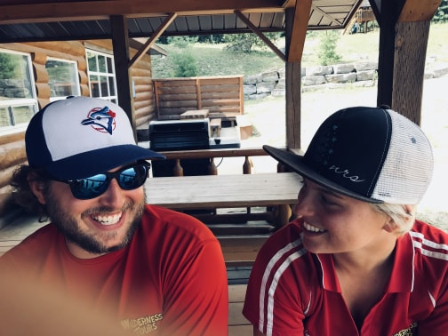  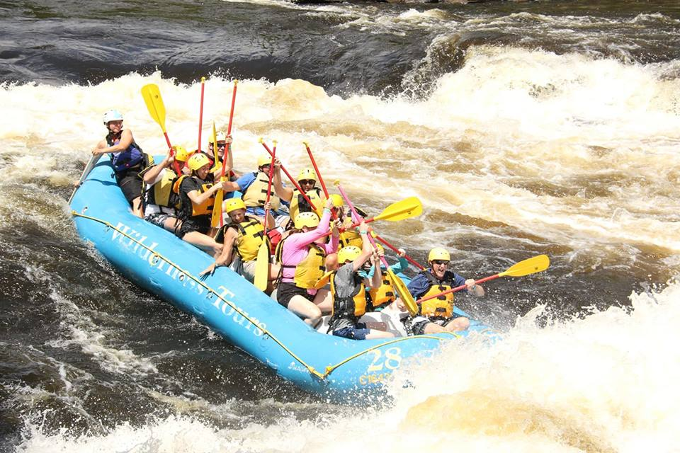 |  |  | Experience  May 2018–August 2018  Whitewater Raft Guide, Ottawa River  Raft Guide on Middle and Main Channel of the Ottawa  Activities Coordinator & Yoga Instructor  Wilderness Tours  May 2017-August 2017  Rock-climbing Instructor  Summer Camp Counselor working with fixed lines, top ropes and ziplines  Jungle Sport Inc  January 2017- August 2017  Yoga Instructor  Creator of Landmarks Yoga Program  Landmark CrossFit  Education  Graduating May 2019  Algonquin College  Outdoor Adventure Diploma  - Rescue Canada Swift water River Rescue Technician Level 2 & 3 courses run by Matt Cuccaro  - Whitewater Rafting Guide training (paddle guiding and oar rigging) courses run by Alex Davey, Joel Kowalski, and Seth Ashworth.  - Risk Management, Outdoor Industry, Adventure Business, and Leadership Courses created by Jeff Jackson  - Paddle Canada Flatwater Tandem Canoe Instructor  - Wilderness First Responder. Course run by Jill Baxter  - Rock climbing, Mountain Rescue, Rope management and Ice climbing courses run by Greg Armenin & Jean Belanger  - Certified Level 1 CSIA Ski instructor & Certified Level 1 CASI Snowboard Instructor  - Paddle Canada Level 2 Sea Kayak Instructor. Course run by Cameron Dube and Breen Trott  - Marketing and New Media Course run by Kate Ming-Son  - Human Resource Course  - Natural Environment, and Ecotourism courses  - Human Resources course run by Pierre Mirault  Education Continued…  Journalism & International Development  University of Kings College, Halifax NS (2014-2016)  Completed two years of a combined honors program before deciding to switch programs to Algonquin College.  Activities/ Interests  Yoga, Brazilian Jiujitsu, Whitewater Kayaking, Rock-climbing, Skiing  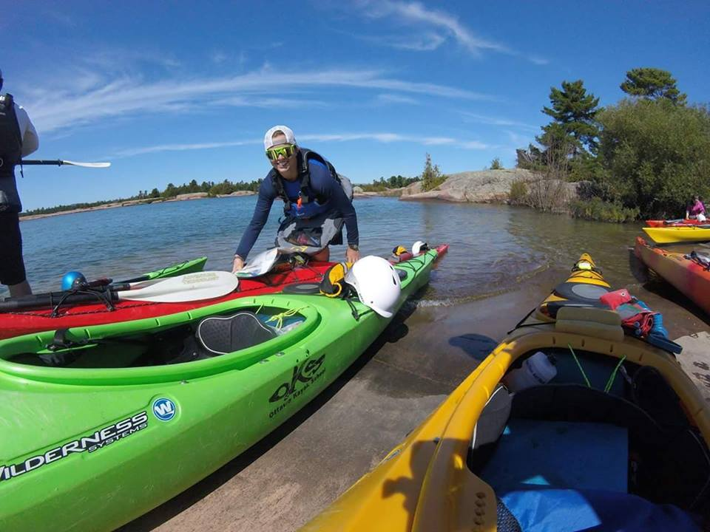  References available upon request

Annika Kate

Bunkis
 | Phone:  613-407-5380
 | Email:  annikabunkis96@hotmail.com

Skills
Rescue Canada Swiftwater Rescue level 3
First Aid CPR/AED Level C
Wilderness First Responder

 | Completion of 200hr Yoga Teacher Training. Course run by Tracy Billows & Paula Munroe at Yogatown  Skills Continued…  Written and published articles for the Halifax Signal  Achieved gold level skating skills through Skate Canada and taught CanSkate for several years  Completed Camp Iawahs Wilderness Leadership training before becoming the Lead Boating Coordinator and multi-day canoe trip guide  Familiar with MINDBODY and various other administrative programs as well as with Microsoft Word, Excel, Publisher and PowerPoint  Completed six years of French immersion classes in High School, and two semesters of Spanish classes at Dalhousie University  Smart Serve certified  Volunteering  Volunteer with Algonquin College JEDI Mentorship program (September 2018-present)  Volunteer with WIND (Wellness Days in Nature) Mental Health Program at Algonquin College (September 2017-present)  Volunteer with Algonquin College Student Connections Program (September 2018-Present)  Volunteer at Yogatown yoga studios, responsible for cleaning the studio and teaching yoga classes for fellow volunteers (October 2016- August 2017)  Volunteer coach for Sacred Heart High School Varsity Girl’s Rugby Team (2017)

